Lab 3- Write Queries to Answer Key Business Questions
Estimated completion time
- 30 minutes

Learning objectives
Upon completion of this lab, students will be able to:

- Recall SQL basics and understand how they apply in Starburst.
- Write and run queries in the Starburst query editor.
- Filter, aggregate, and join data from multiple sources.
- Perform federated joins (e.g., RDBMS + object storage).
- Use Starburst SQL to answer real business questions.

Prerequisites
- Lab 1: Access your lab environment
- Lab 2: Explore Available Data in the Lab Environment

Activities
- Review - SQL in Starburst
- Prepare for the exercise
- Run a basic query
- Filter & aggregate data
- Join across sources
- Answer a business question

Scenario: You want to analyze sales data (in a cloud RDBMS) alongside marketing campaign data (stored as Parquet files in object storage).

Step 1: Review - SQL in Starburst

Starburst SQL is ANSI-compliant, meaning the SQL skills you already know (SELECT, WHERE, GROUP BY, JOIN) apply directly.
In addition, Starburst lets you:

- Query multiple data sources with the same SQL syntax.
- Join across systems without moving data.

Review this tutorial if you need a refresher on basic SQL.

Note: You will be challenged to write several queries in this lab. We suggest you try them on your own before viewing the solutions.

Step 2: Prepare for the exercise
- Sign in and verify that you’re using the students role.



- Navigate to the Query editor.
- Ensure that you have access to the following data sources:
  - bootcamp.sales_db.sales_orders (cloud rdbms)
  - iceberg.marketing_data.campaigns (object storage)

Step 3: Run a basic query

Challenge:

Write a query that returns the number of orders placed each month.

- Order by month

✅Hint: You can use date_trunc('month', order_date)to round each timestamp down to the first day of its month.

Solution:

Here’s one way to it:

SELECT
date_trunc('month', order_date) AS order_month,
COUNT(*) AS sales_count
FROM bootcamp.sales_db.sales_orders
GROUP BY 1
ORDER BY 1;

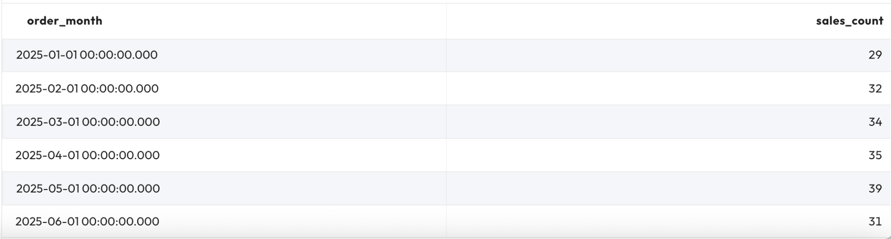

Step 4: Filter & aggregate data

Challenge:

Find the top 5 customers by total sales value.

- Use SUM(order_total) and GROUP BY customer_id.
- Order results by total sales, highest first.

Solution:

SELECT customer_id, SUM(order_total) AS sales_value
FROM bootcamp.sales_db.sales_orders
GROUP BY customer_id
ORDER BY sales_value DESC
LIMIT 5;

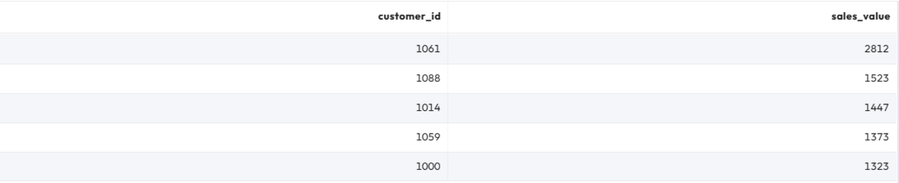

Step 5: Join across sources
Now it’s time to write a federated query to join the sales data, located in cloud RDBMS storage, with the marketing data, located in object storage.

Challenge:

Join sales data with marketing campaigns.

- Show campaign_name, number of orders, and total sales.
- Use COUNT(order_id) and SUM(order_total).
- Order results by total sales descending.

Solution:

SELECT
c.campaign_name,
COUNT(s.order_id) AS number_of_orders,
SUM(s.order_total) AS total_sales
FROM bootcamp.sales_db.sales_orders s
JOIN iceberg.marketing_data.campaigns c
ON s.campaign_id = c.campaign_id
GROUP BY c.campaign_name
ORDER BY total_sales DESC;

Explanation:

This will join the sales_orders with campaigns, then show each campaign’s name, how many orders it drove, and the total sales amount, sorted from highest to lowest sales.

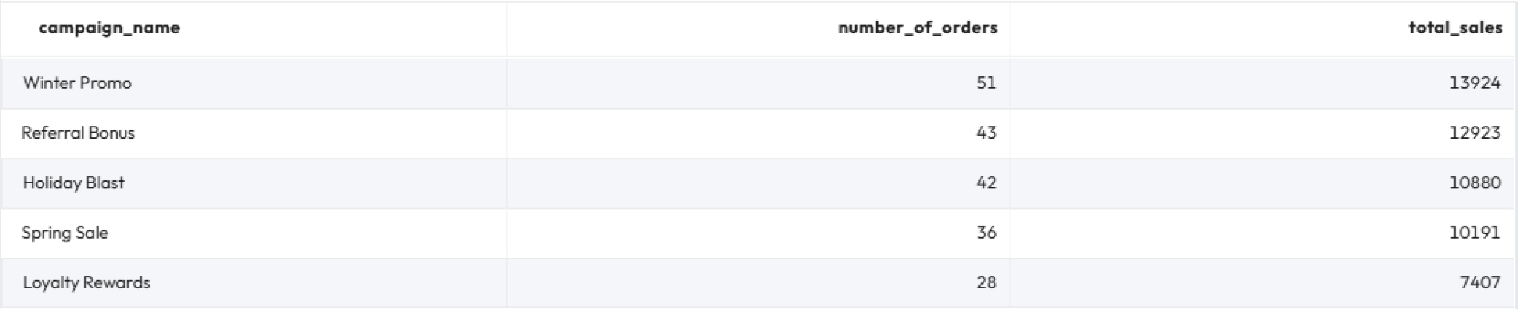

Step 6: Answer a business question

Challenge:

Management asks: “Which marketing campaign drove the highest average order value (AOV) in Q1 2025?”

- Calculate AOV = SUM(order_total) / COUNT(order_id).
- Filter for orders between 2025-01-01 and 2025-03-31.
- Return campaign name and AOV.

Solution:

SELECT
c.campaign_name,
SUM(s.order_total) * 1.0 / COUNT(s.order_id) AS avg_order_value
FROM bootcamp.sales_db.sales_orders s
JOIN iceberg.marketing_data.campaigns c
ON s.campaign_id = c.campaign_id
WHERE CAST(s.order_date AS DATE) BETWEEN DATE '2025-01-01' AND DATE '2025-03-31'
GROUP BY c.campaign_name
ORDER BY avg_order_value DESC
LIMIT 1;

Explanation:
- WHERE (CAST s.order_date AS DATE) BETWEEN ... → casts order_date to DATE and filters orders to Q1 2025.
- SUM(order_total) * 1.0 / COUNT(order_id) → computes Average Order Value (AOV) per campaign (multiplying by 1.0 ensures decimal division instead of integer).
- ORDER BY avg_order_value DESC LIMIT 1 → returns the single campaign with the highest AOV.

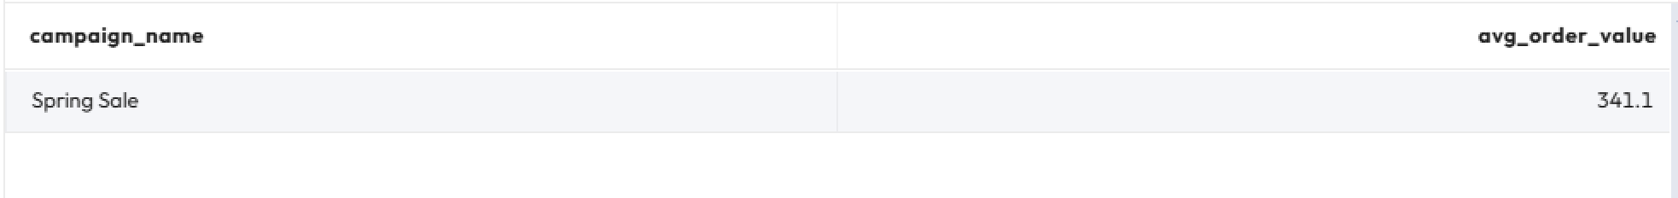

Step 7: Reflect on your work
- What did you notice about writing queries across different sources?
- How did Starburst simplify access to both RDBMS and object storage data?
- Where could this capability save your organization time or money?

END OF LAB EXERCISE

